**Department of Computer Engineering**

**University of Peradeniya CO226-Database Systems**

Lab Sheet Number: 08

Topic: MySQL-PHP Connectivity

Reg. No: E/18/397

1. Write a PHP script to establish a connection to the database. Your script should display the appropriate MySQL connection error message if it is unable to establish the connection.

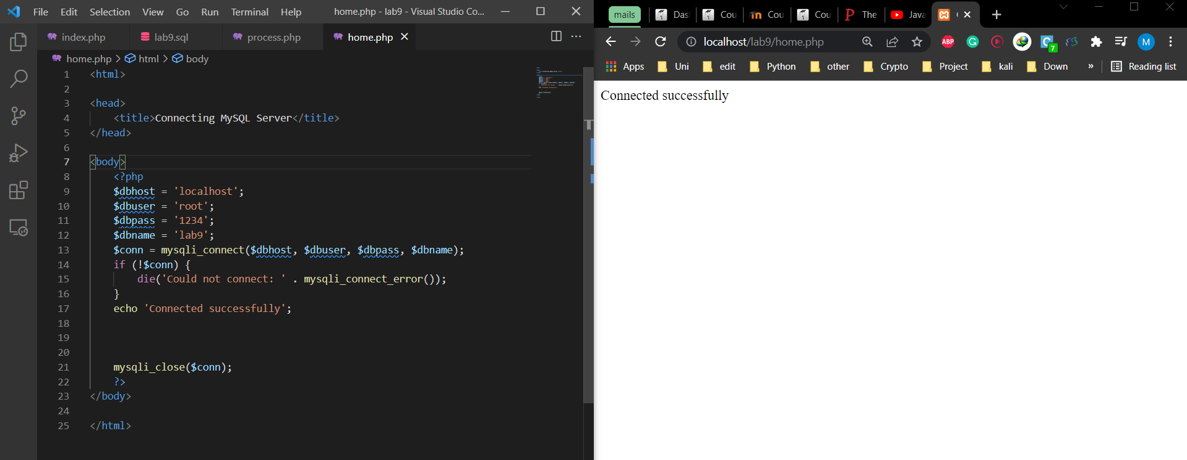

Figure 1: Code and the output of the php connectivity.

2. Modify the script to select the relevant database, create the above table and populate it with data.

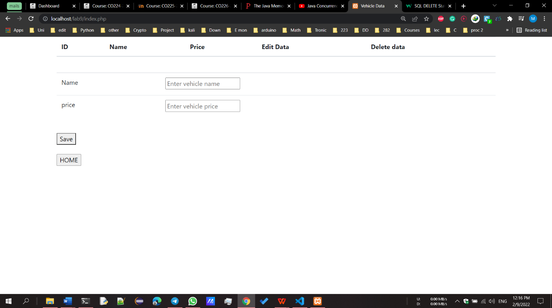

Figure 2: Before populate data to the table (No data in table)

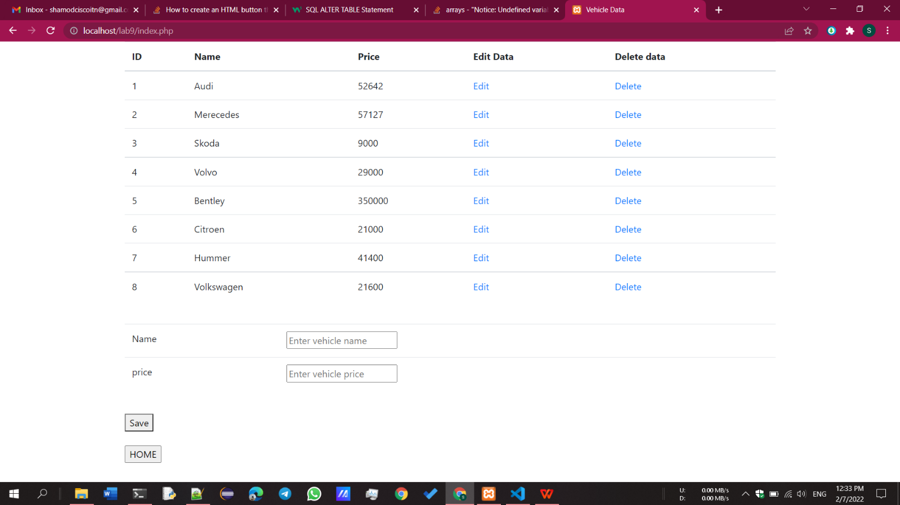

Figure 3: After populating table with data

3. Modify the script to update the price of Volvo to 35,000.

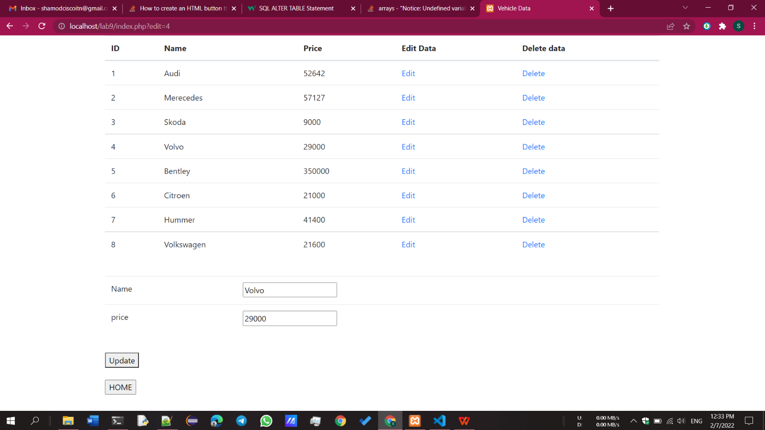

Figure 4: Before editing the price of Volvo

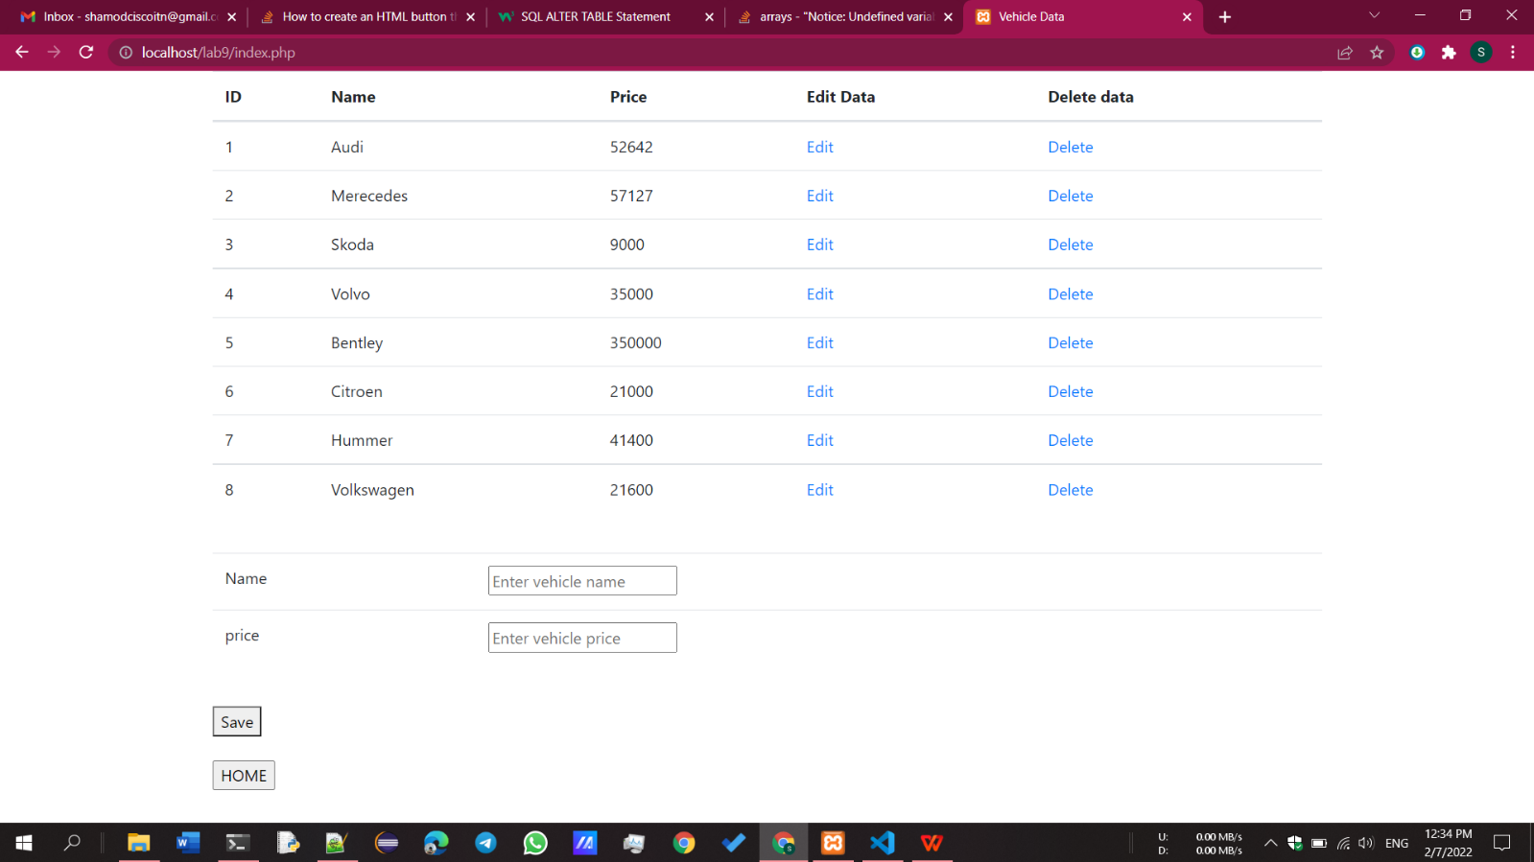

Figure 5: After updating price of the Volvo

4. Modify the script to retrieve all data of the table and display it on the web page.

Figure 6: Displaying all the data in table

5. Delete the record of Hummer through the PHP script

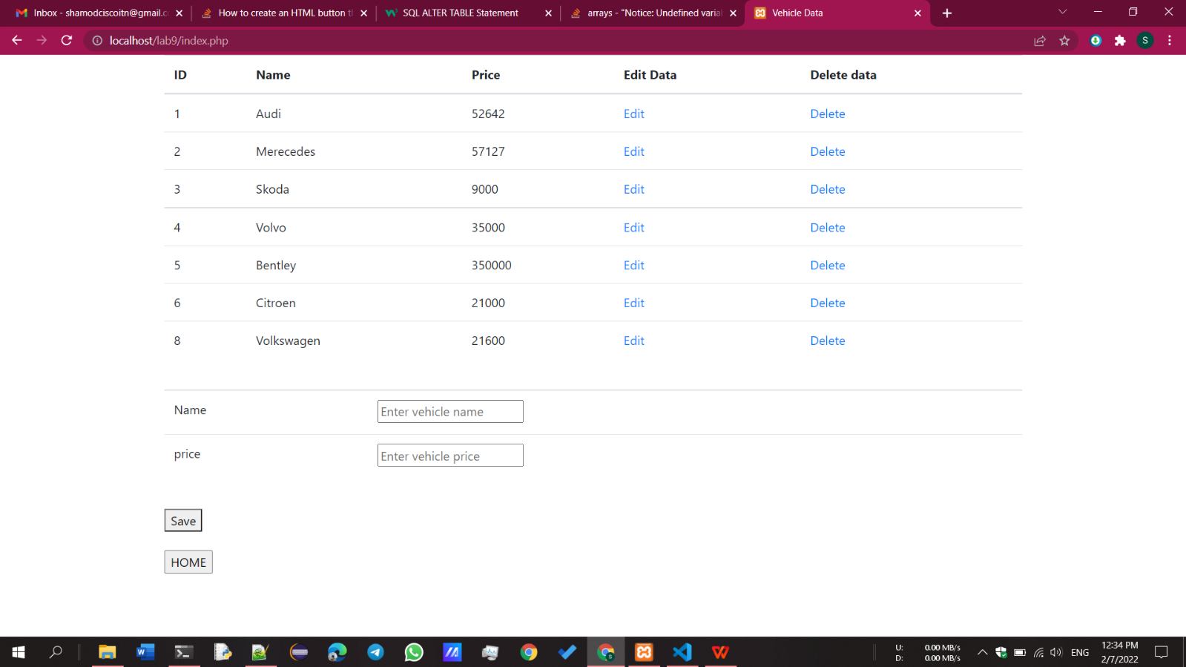

Figure 7: After deleting record of Hummer

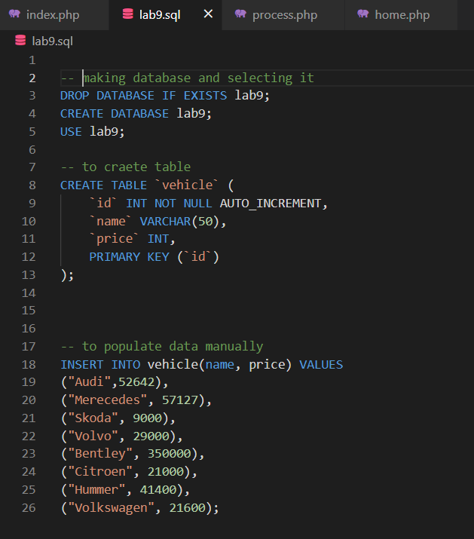

Figure 8: Used SQL syntaxes

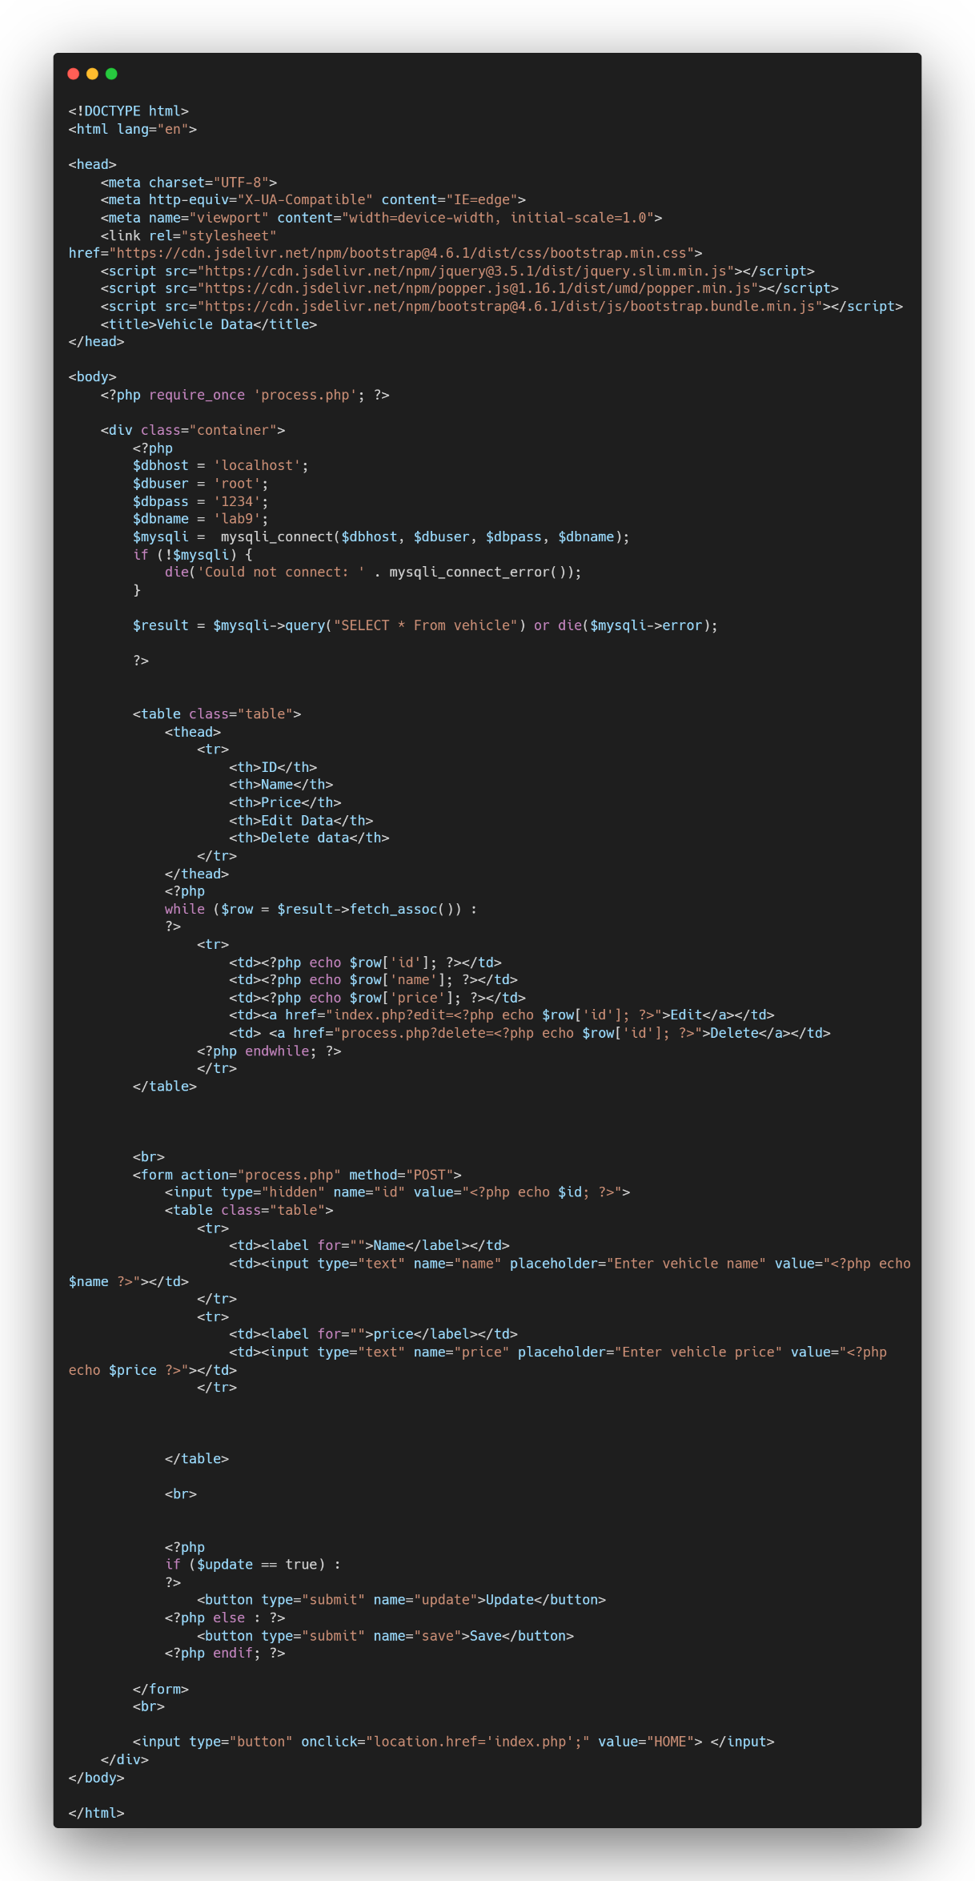

Figure 9: Final front end code (index.php)

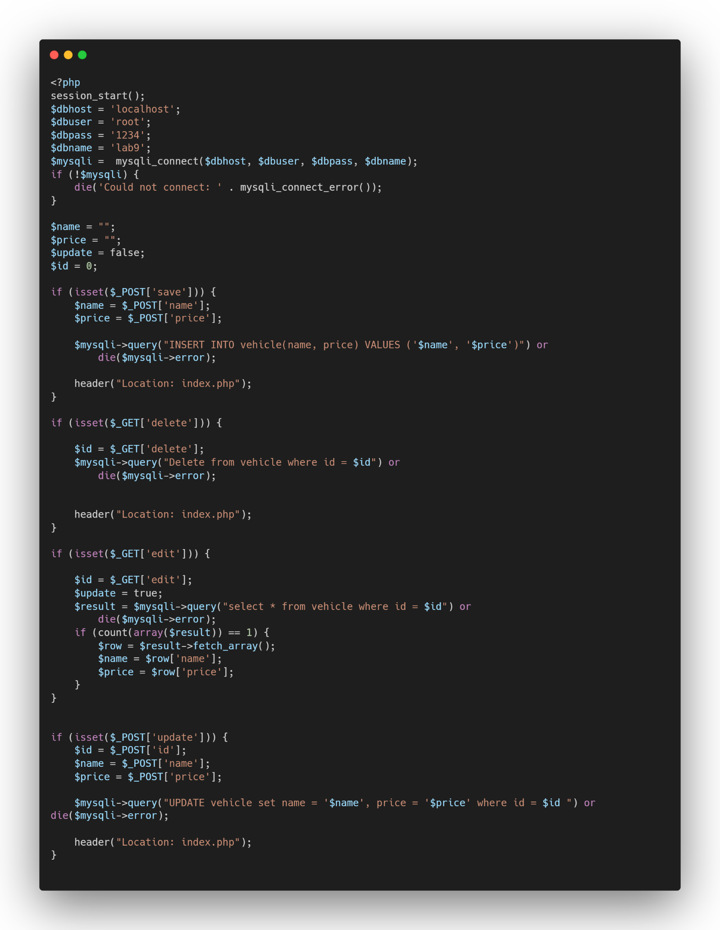

Figure 10: Finalized backend code (process.php)

GitHub repo link: - <https://github.com/ShamodGeevinda/CO226Lab08>